X Class

**L 200 154 004**

**RARA KINANDHA NINGRUM**

Database Management Systems

Role is a collection of permissions that exist in MySQL that are used to manage permissions for each different user. While Grant is the grant command permissions. For this task we are asked to create a role and grant for each user who has created the Owner, Manager, and Cashier. In the Owner's user will be granted all the permissions will be database "classicmodels". In the user the Manager is granted permissions "SELECT, UPDATE, INSERT, and DELETE". While the cashier user will only be granted permissions "SELECT and INSERT". for more will be explained on the next page.

Creating ROLE on the database "classicmodels".

And will be grouped into 3 namely Owner, Manager, and Cashier.

1. Sign in to the " cl assicmodels " database and create the desired role .



Command for make ROLE is :

CREATE ROLE namaROLE, namaROLE, ...;

2. Give right access for all that ROLE has created .

-        Owner               : will given whole right access

-        Manager               : given right access SELECT, UPDATE, INSERT, DELETE

-        Cashier               : given right access SELECT and INSERT

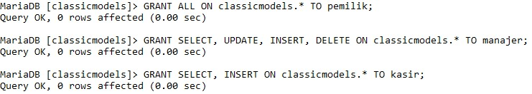

Command for description right access on ROLE are :GRANT hakAkses ON namaDatabase.namaKolom TO namaROLE;

3.  After that USER ACCOUNT make will given right access certain .

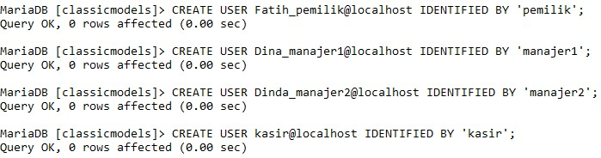

Command for make USER is :

CREATE USER namaUser@host IDENTIFIED BY ‘password’;

4. Give right access Reviewed by USER ROLE who has created previous with GRANT command .

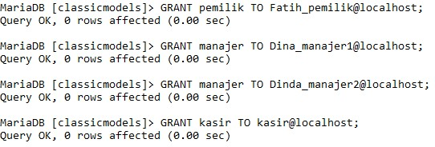

Command for give right access on USER:

GRANT namaROLE TO namaUSER@host;

5.  Sometimes USER doesnot on automatic could directly The role access. Then must required for activate more first with command :

SET ROLE namaROLE;

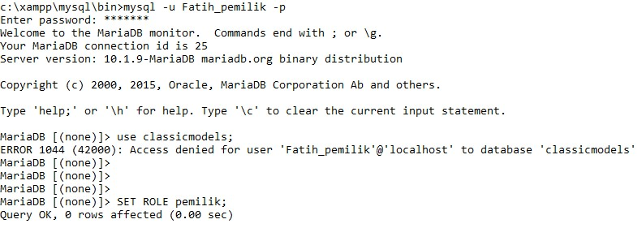

New can we could access it .

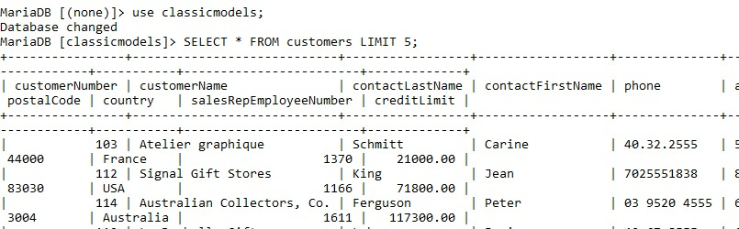

6. Do with the same thing in the Manager user and The cashier to be able access . In the Manager user

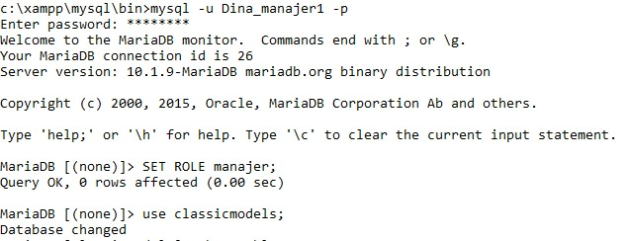

On Cashier user